Available online at [www.sciencedirect.com](http://www.sciencedirect.com/)



AASRI Procedia 3 (2012) 577 – 582

# 2012 AASRI Conference on Modeling, Identification and Control

Autooscillations in Thermo-responsive Polymer Solutions as the Basis for a New Type of Sensor Panels

I.Suleimenova*, G.Munb, R.Ivlevc, S.Panchenkoa,b, D.Kaldybekovb

*aAlmaty University of Power Engineering and Telecommunications, 126 Baitursynova, Almaty 050013, Kazakhstan*

*bKazakh National University, 71 Al-Farabi, Almaty 050038, Kazakhstan*

*cKazakh-British Technical University, 59 Toli bi, Almaty 050000, Kazakhstan*

**Abstract**

It has been shown experimentally that regular autooscillations may arise in thermo-responsive polymer solutions that are in the temperature gradient fields. The theoretical interpretation of the observed phenomena is given. This paper shows that these phenomena can be used for the development of new sensor panels.

© 2012 The Authors. Published by Elsevier B.V. Open access under [CC BY-NC-ND license.](http://creativecommons.org/licenses/by-nc-nd/3.0/)

© 2012 I. Published by Elsevier B.V. Selection and/or peer [review under responsi](http://creativecommons.org/licenses/by-nc-nd/3.0/)bility of American Applied Science Research Institute

Selection and/or peer review under responsibility of American Applied Science Research Institute

*Keywords:* waves, self-organization, non-equilibrium environments

#### Introduction

The studies of self-organization processes in stimuli-responsive polymer solutions have long attracted the close attention of researchers Zaslavsky, 1988. (In particular, it is connected with attempts to discover the mechanism of evolution that preceded the biological, i.e. to find out in what way the life began on the Earth exactly Ergozhin at al., 2008.)

* Corresponding author. Tel.: +7-705-295-29-19;

*E-mail address:* [esenych@yandex.ru.](mailto:esenych@yandex.ru)

2212-6716 © 2012 The Authors. Published by Elsevier B.V. Open access under [CC BY-NC-ND license.](http://creativecommons.org/licenses/by-nc-nd/3.0/) Selection and/or peer review under responsibility of American Applied Science Research Institute doi:10.1016/j.aasri.2012.11.091

As we known, one of the simplest examples of self-organization in open non-equilibrium systems are auto- oscillations Zaslavsky, 1988 that are capable of, under certain conditions, turning into a wave mode.

In this paper, it is shown that autooscillations of a previously unknown type may occur in the solutions of thermo-responsive polymers which are well-studied substances Khutoryanskiy, 2004, and they can exist in the form of waves the direction of propagation of which depends on the temperature gradient orientation, as well. These oscillations appear under condition that the solution is of a temperature close to the temperature of the phase transition.

#### Experimental

In this paper, 2% solution of copolymer N-isopropylacrylamide (NIPAAm) and acrylic acid (AA) in the ratio of molar concentrations 90:10 at pH=7.6 between 26 and 40 o was investigated. Our investigated solution has a phase transition temperature around 32oC at which it reaches sharp turbidity (increase in optical density). It enables to measure the content of macromolecules that partially transformed into a soluble form using turbidimetry (intensity measurement of the light transmitted through the solution). Furthermore, there is a possibility to investigate the variation in the number of macromolecules that change their state by measuring optical density fluctuations.

The dependence of the relative intensity of light transmitted through the solution on the time has been registered. The time resolution of the used equipment was about 1 ms; Per unit has taken a value corresponding to the intensity of the light transmitted through the cell at the initial time.

The solution was placed in a rectangular cell with optically transparent walls cooled by external water jacket. Inside the cuvette wire element was situated that provides heating to required temperature of the solution.

#### Results

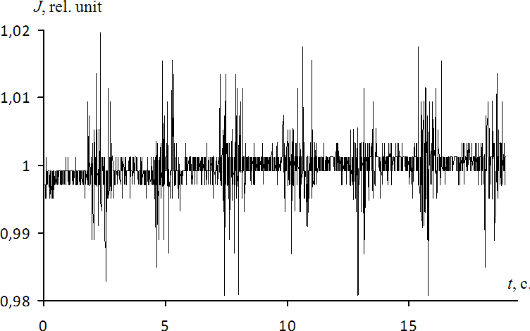The results of samples are presented in Figures 1 and 2. It is seen that the optical density of the solution was exposed to periodic fluctuations in Fig. 3, in which as shown the result of the procedure application of numerical filtering to the mean-square deflection of measured values have been presented in Fig. 1.

Fig. 1. The dependence of the relative intensity of emission transmitted through the cell on the time;  38 o.

It can be seen that the state of a thermo-responsive polymer solution near the phase transition is characterized by optical density fluctuations, which are of regular (periodic) character.

Qualitatively, the appearance of such fluctuations can be explained as follows. The dependence of the optical density of thermo-responsive polymer solution on the temperature has an expressed nonlinear character. This corresponds to the fact that in the transition region of dynamic equilibrium is established: part of the molecules that have passed to a partially soluble state transforms into swollen macromolecular coil, and some experience the reverse transition.

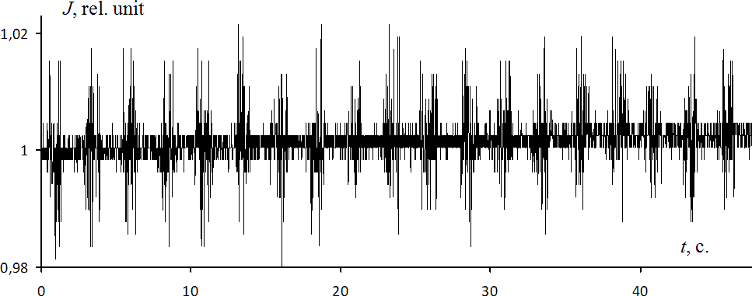

Fig.2. The dependence of the relative intensity of emission transmitted through the cell on the time;  37 o

In the equilibrium state the frequencies of both these indicated transitions, theoretically should be the same. But this balance can be disrupted due to a number of reasons one of which is auto-oscillations and waves that arise spontaneously in a thermodynamically open system of considered type.

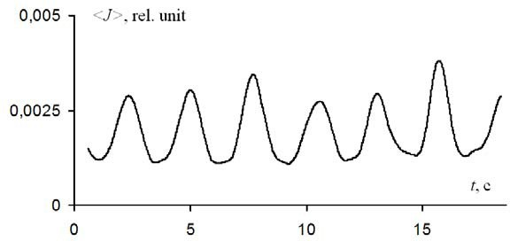

Fig. 3. The result of the application of numerical filtering to the mean-square deflection of the relative intensity of emission, used the data from Fig. 1.

#### Discussion

Constructing of a theory explaining regular auto-oscillations, in particular, allows to demonstrate the nature of occurrence of such as these fluctuations are closely linked with the factor of phase transition inertia. Notably, there is a certain delay between the point in time when the macromolecule acquires temperature that

is sufficient to move into a partially insoluble state as well as, in fact, the moment of the actual phase transition.

The equation that describes the temperature distribution in given cell in both space and time can be written as follows:

*C*

*T*

*t*

*a* 22*T*

*q T t T t*

*(1)*

where *a* 2 - coefficient of thermal diffusivity, *C*

*a cV* , *a*

- water density, *cV* - heat capacity of water at

constant volume, *T* - frequency of direct and inverse phase transition, *q* - hidden heat of phase transition.



The choice of sign the right side of equation (1) corresponds to the assumption of endothermic nature of the formation of partly insoluble molecules above the critical temperature. (i.e. it is assumed that the conversion

of macromolecules into a slightly swollen coil the energy is expended.) The sign *T t* corresponds to the



assumption that the transition frequencies are determined not only by the value of temperature at a given time, but the nature of other changes in the previous period as well.

In the equilibrium state when the fluctuations are absent (background task) the temperature profile is determined by the solution of the equation

2 2



*T*0

*t*

*T*

*a*

0

*C*

0

*(2)*

with the appropriate boundary condit~ions. If the cylindrical symmetry of task the function *T*0 *r * depends

only on the radial coordinate *r* . Define *T * *T T*0 - the function the temperature variations relatively to the

background profile, which as follows from the given record may take negative values. Equation (1) would be

linearized under standard procedure substituting in it the expansion ~

*T*

~

 *T * *T*0

and keeping in consideration

the members that are not higher than the first degree according to *T* . We have:

~



*t*

*T*

0



*t*

*T*

0



*C T a* 2 ~

2

*T*

*t*

/

*T*

*t*

/

*T*

### *t*

*K t * *t* / ~

*dt* /

*K t * *t* / ~

*dt* /

*(3)*

where *K t* - nuclei of linear integral operators that describe delay in time frequency response of the

direct and reverse phase transitions on the temperature change.

In the simplest case, when the time delay has a strictly particular value, equation (3) becomes

~



### *C T a* 2



*T*



*t*

~ ~

*T * *T*

2

*t*

*T*0

*(4)*

(This case responds to the  -typed form of depending *K t*

function on the time). The derivate

## *T T T*



*(5)*

can be considered constant in case the temperature gradient in given system is small (temperature of the

cells' walls is maintained close to the temperature by the heating element), correspondingly *T*0

 *const* .

The sign of the derivative (5) near the phase transition temperature, obviously is positive, as in this temperature range the frequency of direct phase transition increases with the growth of variable *T*, and the frequency of reverse phase transition behaves oppositely

There is should be option (4) as:

~ *t*,**r**

*T*

*A*exp *i t*

 *i***kr**

*, (6)*

setting the background temperature distribution over the cross section of the cell that close to the homogeneous.

Putting (6) into (4), we have:

where introduced the legend

*i*

.



1

~

*C T*

*a* 2**k** 2

 exp *i* 0

*(7)*

The correlation (7) can be considered as the dispersion law for oscillations the development in the considered system.

Rewrite (7) in a form that explicitly include the real and imaginary parts.

*i * *a* 2**k** 2

 cos

*i* sin

*(8)*

There is a definite value of the frequency at which in the system may be sustained (and do not enhancing) oscillations. This value is clearly determined from the condition





  sin *(9)*

Qualitative behaviour of the solution (9), depending on conditions can be set on the basis of Figure 4 which postponed two auxiliary depending

*S *  *, S*

 sin

*(10)*



which are responsible to the solution of equation (9).

As presented construction shows, in particular, the existence of stable wave can take place only at

sufficiently large parameters

 1/  . In fact, the criterion (12) is even more rigid, because along with the

*a* 2 **k** 2

condition (7) must satisfy the equation

cos

, that also illustrated in Figure 4.



Thus, this type of oscillations may develop in the system only at sufficiently large values of  . Physically, it corresponds with significant dependence of the transition frequency on temperature, which is confirmed in

the cases of a number of polymers. Apparently, these conditions are satisfied, in particular, for used copolymer NIPAAm:AK 90:10 in experiments.

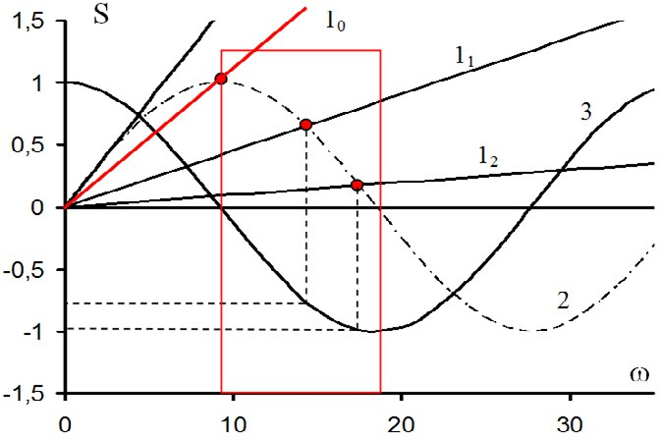Thereby, the inertia of changes in the characteristics of the system during phase transitions can lead to the appearance of oscillations of a previously uninvestigated type.

Fig. 4. Determination of the tolerance range parameter

#### Conclusion

Thus, there are conditions under which previously unknown type of waves can develop in liquid phase development. It is essential that such environments can be converted into a film by the use of cross-agents (gel formation, i.e. crosslinked polymer network). Moreover, the detection of waves of this type can be carried out by optical as well as electrical devices. This is due to the fact that with the loss of solubility the degree of ionization of macromolecules is reduced rapidly. In turn, this leads to the dramatic increase in local value of the specific resistance of solution.

Mentioned factors allow us to assert that these waves could potentially be used to create sensor panels as similar to the panel on surface acoustic waves. The principle of operation of such panels, probably, could be based on the changing conditions of the wave propagation under mechanical impact on a local part of the surface.

#### References

1. Zaslavsky G.M., Sagdeev R.Z. Introduction to nonlinear physics. From pendulum to turbulence and chaos.

- Moscow : Science, 1988.(in Russian)

1. Ergozhin E.E., Zezin A.B., Suleimenov I.E., Mun G.A. Hydrophilic polymers in nanotechnology and nanoelectronics (monography) / Library of nanotechnology, Almaty - Moscow: LEM, 2008, 214 p (in Russian)
2. Khutoryanskiy V.V., Nurkeeva Z.S., Mun G.A., Sergaziyev A.D., Kadlubowski S., Fefelova N.A., Baizhumanova T. Rosiak J.M. Temperature-responsive linear polyelectrolytes and hydrogels based on [2- (methacryloyloxy)ethyl]trimethylammonium chloride and N-isopropylacrylamide and their complex formation with potassium hexacyanoferrates (II, III) // J. Polym. Sci., Polym. Phys., 2004, V.42 (3), P. 515- 522.